**Memory Recall UI Design in Figma**

**M.SHERYL KATRINA**

**230701310**

**A. Home Screen (Instruction Page)**

1. Create a new frame (1024x768px) in Figma.
2. Add a heading: "Memory Recall Task."
3. Include instructions: "You will be shown several groups of icons or text. After viewing, recall the items you remember."
4. Create a "Start" button using a rectangle and text, linking it to the Chunking Phase.

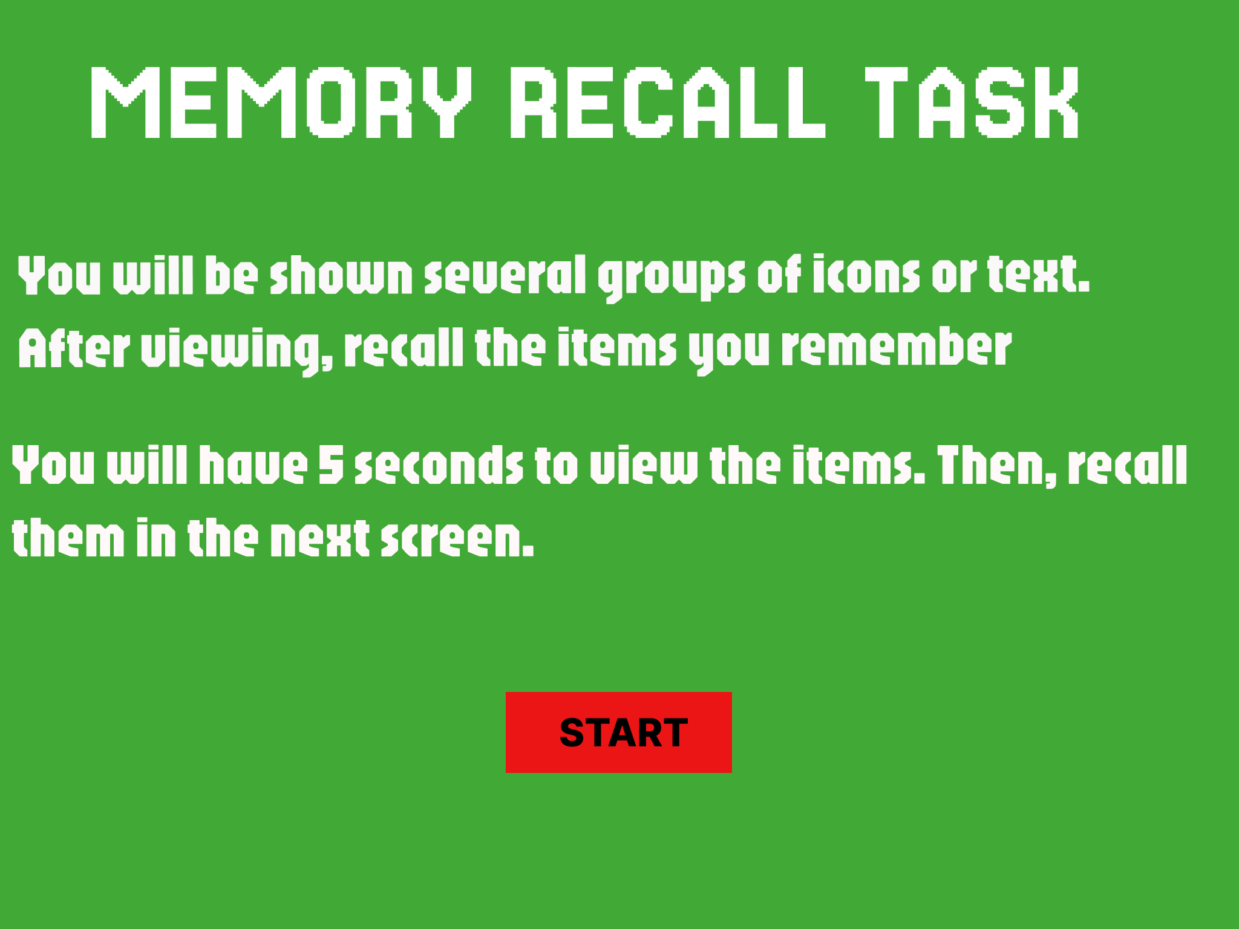

**B. Chunking Phase (Displaying Chunked Items)**

1. Create a new frame displaying icons or text.
2. Design chunked items:
   * Group 3-5 items together using rectangles.
   * Space out groups for clarity.
3. Set a transition delay of 5 seconds before moving to the Recall Phase.

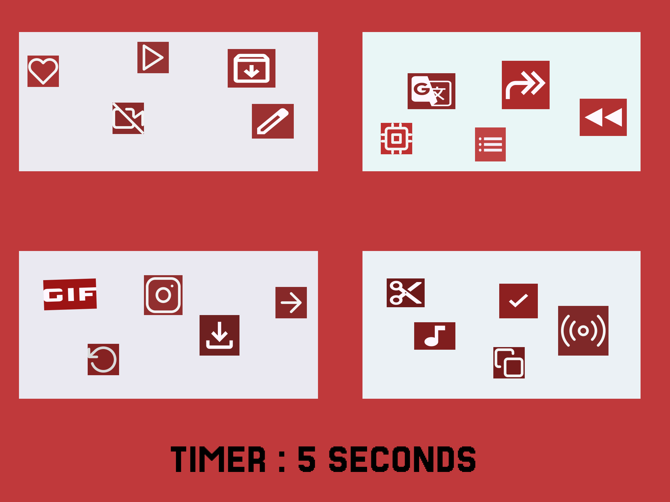

**C. Recall Phase**

1. Create a new frame for recall.
2. Add multiple-choice options or text input fields for user responses.
3. Include a "Submit Recall" button linking to the Feedback Screen.

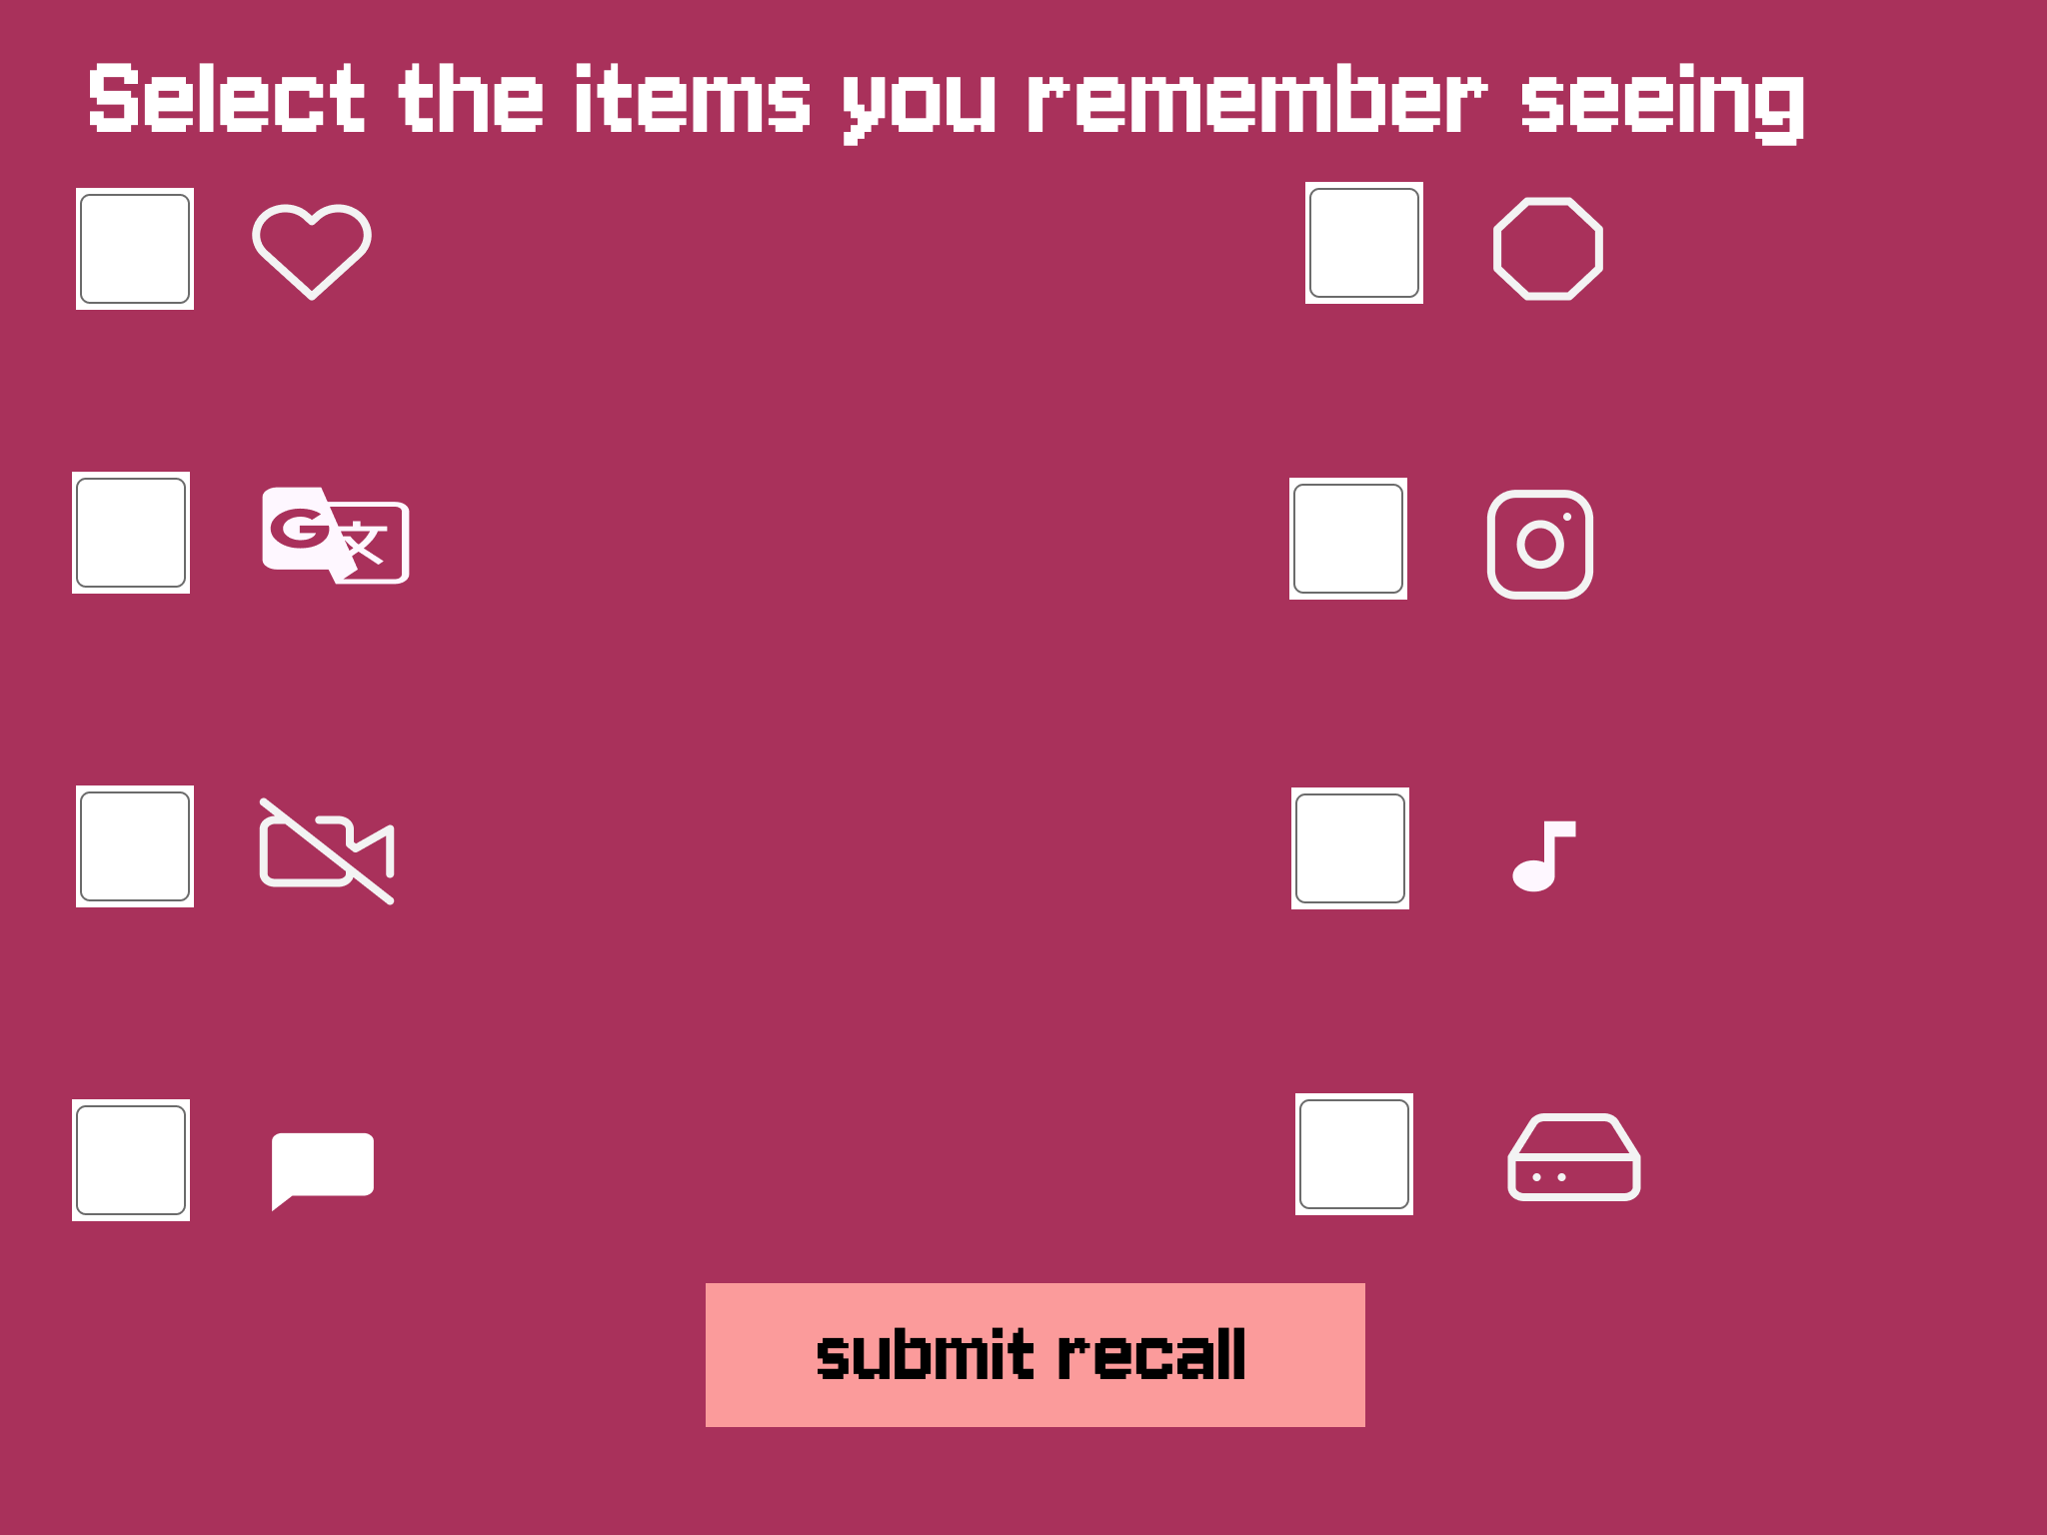

**D. Result Screen**

1. Display feedback based on recall accuracy (e.g., "You recalled 4/5 items correctly!").
2. Analyze chunking impact by varying chunk size and type.

